Think of a DBMS (Database Management System) as a sophisticated "Librarian."
If the Database is the library (the physical collection of books/data), the DBMS is the librarian who knows exactly where every book is, prevents two people from grabbing the same book at once, and ensures that only authorized people can enter the "restricted" section.
What is DBMS?
Technically, a DBMS is a software suite designed to define, store, retrieve, and manage data. It acts as an interface between the user and the database, ensuring that data is organized and easily accessible.
- What it is: Software (like MySQL, Oracle, PostgreSQL).
- What it does: Manages the Data, the Database Engine, and the Database Schema
Advantages of DBMS (The "Why we use it")
In an interview, don't just list these—explain them using the "Problem vs. Solution" approach.
1. Controlled Data Redundancy
- The Problem: In a file-based system, the same student info might be in the "Library" file and the "Accounts" file. If they change their phone number, you have to update it in two places.
- The DBMS Solution: Data is integrated. You store the phone number once, and all departments access that same record. This saves space and prevents "Data Inconsistency."
2. Data Sharing and Concurrency
- The Problem: If two people try to book the last seat on a flight at the exact same millisecond in a simple file, both might think they got it.
- The DBMS Solution: It uses Concurrency Control. It locks the record for the first user, making the second user wait
until the first transaction is finished.
3. Data Integrity
- The Problem: Someone accidentally enters a "Text" in a "Salary" field or enters a negative age.
- The DBMS Solution: You can set Constraints. For example, CHECK (Age > 18). The DBMS will literally refuse to save invalid data.
4. Data Security
- The Problem: In a file system, if you have access to the file, you see everything.
- The DBMS Solution: You can provide Level-based Access.
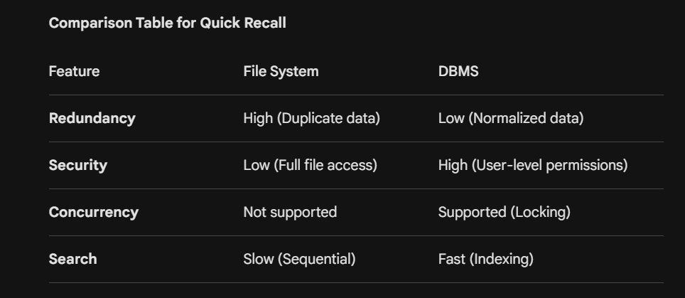
- Example: A HR manager can see salaries, but a Team Lead can only see employee names and skills.
5. Backup and Recovery
- The Problem: If a computer crashes while saving data in Excel, the file often gets corrupted.
- The DBMS Solution: It maintains a Log. If the system crashes mid-transaction, the DBMS uses the log to "Undo" the partial change (Rollback) or "Redo" it to ensure the database remains healthy.
6. Data Independence
- The Problem: In old systems, if you changed the file format from .txt to .csv, you had to rewrite your entire software code.
- The DBMS Solution: The internal storage structure can change without affecting the user's view. This is called Metadata (Data about Data) management.

1. What is a Database (DB)?
A Database is simply an organized collection of structured information, or data, typically stored electronically in a computer system.
- The "What": It is the actual container of the data.
- The Analogy: Think of a database as a digital filing cabinet. It doesn't "do" anything on its own; it just holds the folders (tables), papers (records), and ink (data).
- Real-World Scenario: On Amazon, the database is where your username, password, and order history are physically stored.
2. What is a Database System (DBS)
A Database System is the "Big Picture." It is the combination of the Database, the DBMS (the software), and the Applications that use it.
Formula: Database System = Database + DBMS + Application Programs + Users.
- The "How": It refers to the entire environment that allows you to manage and interact with the data.
- The Components:
  - Database: The raw data.
  - DBMS: The software (like MySQL or Oracle) that manages the data.
  - Application: The interface (like a mobile app or website) where you click buttons to see data.
  - Users: The people (Admins or End-users) interacting with the system.
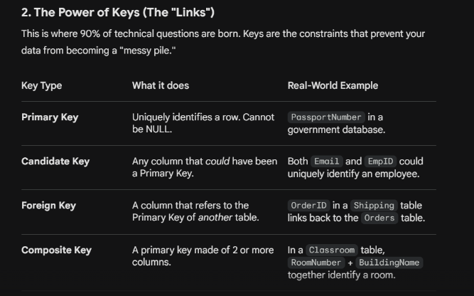
Interviewer Tip: If they ask, "Is a DBMS always better?", be honest. For very small, single-user applications, a DBMS might be "overkill" because it's expensive and requires more memory/CPU power than a simple text file.

Q1: "Can a Database exist without a DBMS?"
How to answer: "Technically, yes. A collection of files on a hard drive is a 'database' in the broadest sense. However, without a DBMS, you have no efficient way to search, secure, or share that data. It’s like having a library where all the books are piled in a mountain on the floor—the data is there, but you can't use it."
Q2: "What is Metadata and where does it live?"
How to answer: "Metadata is 'data about data.' It defines the structure (e.g., that the 'Age' column must be an integer). In a Database System, this is stored in the Data Dictionary or System Catalog. This is what allows the DBMS to know how to handle your queries."
Q3: "What are the different types of Databases?"
- Relational (RDBMS): Data in tables (MySQL, SQL Server). Best for structured data.
- Non-Relational (NoSQL): Data in documents or graphs (MongoDB). Best for unstructured/massive data.
- Distributed: Data stored across multiple physical locations.
RDBM
Think of RDBMS as a "Strict Manager" for your data. It doesn't just store info; it enforces rules to ensure that every piece of data is accurate, reachable, and logically connected.

1. The Relational Model: Core Components
In an RDBMS, data is viewed as a collection of Relations (Tables).
- Attribute (Column): A specific property of an entity (e.g., Price, Email).
- Tuple (Row): A single, unique record in a table.
- Domain: The set of permitted values for an attribute. (e.g., a Month domain is 1-12).
- Degree: The number of columns in a table.
- Cardinality: The number of rows in a table.

3. Data Integrity Constraints
The interviewer might ask: "How does RDBMS ensure the data is correct?" You answer by mentioning Integrity Constraints:
- Entity Integrity: No part of a Primary Key can be NULL. You must be able to identify every record.
- Referential Integrity: A Foreign Key must always point to an existing Primary Key. You cannot have an "Order" for a "Customer" that doesn't exist.
- Domain Integrity: Data must follow the defined format (e.g., you can't put "ABC" in a Date field).

4. The 3 Types of Relationships
RDBMS allows us to map real-world scenarios into tables:
- One-to-One (1:1): One person has one Passport. (Rarely used; usually merged into one table).
- One-to-Many (1:N): One Customer can place many Orders. This is the most common relationship.
- Many-to-Many (M:N): Many Students can enroll in many Courses.

Interview Tip: You cannot implement M:N directly in RDBMS. You must create a Junction Table (or Mapping Table) in the middle.

5. Popular RDBMS Software
When they ask which ones you know, be ready to mention:
- MySQL: Open-source, very popular for web apps.
- PostgreSQL: Advanced, handles complex queries and large data sets well.
- Oracle: Enterprise-level, highly secure, and expensive.
- SQL Server: Microsoft's offering, integrates perfectly with .NET environments.

6. Real-World Interview Scenarios
Scenario A: "Why use RDBMS over NoSQL (like MongoDB)?"
- Answer: "Use RDBMS when your data structure is fixed and you need ACID compliance. If I’m building a Banking system, I need RDBMS because consistency is non-negotiable. If I’m building a social media feed with unpredictable data, I might look at NoSQL."

Scenario B: "What happens if I try to delete a record that is a Foreign Key in another table?"
- Answer: "The RDBMS will stop you to maintain Referential Integrity. However, we can use ON DELETE CASCADE to automatically delete the child records, or ON DELETE SET NULL to keep the child records but remove the link."

Scenario C: "Can a table have two Primary Keys?"
- Answer: "No, a table can only have one Primary Key. However, that Primary Key can consist of multiple columns (called a Composite Key)."

LANGUAGES IN SQL

In a DBMS interview, when you are asked about "Database Languages," the interviewer is looking for your knowledge of SQL (Structured Query Language) and how it is categorized based on functionality.
Think of it this way: To build a house, you need tools to create the foundation (DDL), tools to move furniture in and out (DML), tools to control who has the keys (DCL), and tools to make sure the sale is final (TCL).

1. DDL (Data Definition Language)
DDL is used to define the schema or structure of the database. These commands are generally auto-committed (saved immediately).
- CREATE: To create the database or its objects (tables, indexes, views).
- ALTER: To modify the existing structure (e.g., adding a new column to a table).
- DROP: To delete the entire table structure and its data.
- TRUNCATE: To remove all records from a table, but the structure remains.
- RENAME: To rename an object.
Scenario: "I am launching a new feature and need a table to store user addresses." You would use DDL (CREATE TABLE) to build that structure.

2. DML (Data Manipulation Language)
DML is used to manage the data within the schema. This is what developers use most frequently in their code.
- INSERT: To add new rows of data.
- UPDATE: To modify existing data.
- DELETE: To remove specific rows (usually with a WHERE clause).

3. DQL (Data Query Language)
Some textbooks group this under DML, but in interviews, it’s often separated because it's the most common operation.
- SELECT: Used to retrieve data from the database.
Interview Tip: If asked to "fetch the top 5 earners," you are using DQL.

4. DCL (Data Control Language)
DCL is used to provide security and control access to the data. This is primarily used by Database Administrators (DBAs).
- GRANT: Gives a user permission to perform specific tasks (like reading or writing to a table).
- REVOKE: Takes away those permissions.

5. TCL (Transaction Control Language)
TCL is used to manage transactions to ensure the database stays consistent (part of the ACID properties).
- COMMIT: Saves all the work done in the current transaction permanently.
- ROLLBACK: Undoes the changes if an error occurs (like an "Undo" button).
- SAVEPOINT: Sets a "checkpoint" within a transaction so you can roll back to a specific part rather than the very beginning.

Possible Interview Questions (The "How" and "Why")
Q1: "What is the difference between DELETE and TRUNCATE?" (The #1 most asked question)
- DELETE: Is a DML command. It removes rows one by one and logs each deletion. Because it is logged, you can Rollback (undo) it. You can use a WHERE clause to delete specific rows.
- TRUNCATE: Is a DDL command. It deallocates the entire data page. It is much faster but generally cannot be rolled back in many systems. It removes all rows and cannot use a WHERE clause.
Q2: "Which language category handles the ACID property of Atomicity?"
- Answer: TCL. Using COMMIT and ROLLBACK ensures that a series of operations either all succeed or all fail together.
Q3: "Can you ROLLBACK a DROP TABLE command?"
- Answer: "In most RDBMS (like MySQL), No. Since DROP is a DDL command, it performs an implicit commit. Once the structure is gone, it's gone unless you have a separate backup."

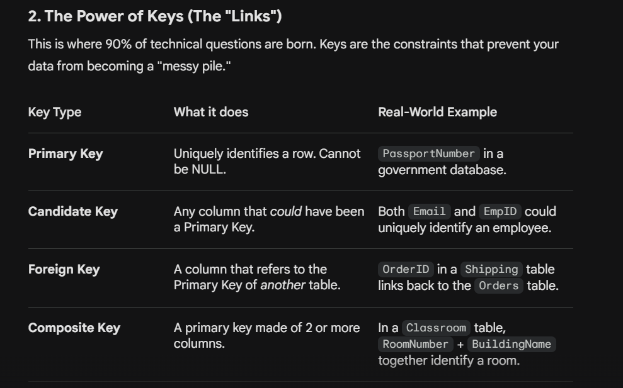

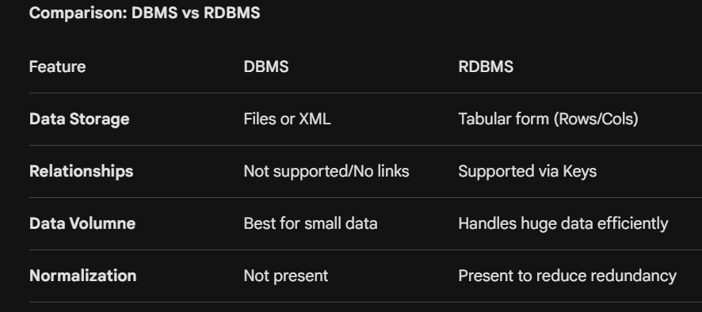

ACID PROPERTIES
best way to explain ACID is through the Bank Transfer Scenario:
- Scenario: You are transferring $100 from Account A to Account B.
- Step 1: Read Account A's balance.
- Step 2: Subtract $100 from Account A.
- Step 3: Add $100 to Account B.
1. Atomicity: The "All or Nothing" Rule
The Philosophy: A transaction might involve 10 different SQL commands. Atomicity treats them as a single unit. If the 9th command fails, the previous 8 are undone.
- Mechanism (The Log): The DBMS maintains an Undo Log (or Transaction Log). Before it changes any data on the disk, it writes the "Old Value" and "New Value" into the log.
- The Fail Case: Imagine a "Save" operation in a game. If the power cuts while saving, you don't want a "half-saved" corrupted file. You want the system to revert to the last working save point.
- Interview Answer: "Atomicity is managed by the Transaction Manager using Rollback and Commit operations. If a failure occurs, the recovery system reads the logs and 'undoes' any uncommitted changes."
2. Consistency: The "Rule Follower"
The Philosophy: Consistency ensures that a transaction takes the database from one valid state to another. It is about the "Health" of the data.
- Mechanism (Constraints): The DBMS uses Integrity Constraints to enforce consistency:
  - Unique Constraints: Ensuring no two users have the same ID.
  - Foreign Key Constraints: Ensuring you can’t delete a customer who still has active orders.
  - Check Constraints: Ensuring a "Salary" column doesn't have negative numbers.
- The Fail Case: If a transaction transfers money but "forgets" to deduct it from the sender, the "Total Money" in the bank increases out of nowhere. The database is now Inconsistent.
- Interview Answer: "Consistency is a shared responsibility. The Developer must write logically correct code, and the DBMS enforces the schema rules (Keys, Data Types, and Constraints)."
3. Isolation: The "Privacy" Guard
The Philosophy: In the real world, thousands of people use a database at once. Isolation ensures that Transaction A doesn't see the "mess" made by Transaction B until B is finished.
- Mechanism (Locking & Timestamps):
  - Shared Lock (Read): Multiple people can read at once.
  - Exclusive Lock (Write): Only one person can modify. Others must wait.
- Isolation Levels (The "Pro" Knowledge):
  - Read Uncommitted: (Lowest) You can see "Dirty Data."
  - Read Committed: You only see finalized data.
  - Repeatable Read: You are guaranteed the data won't change while you are looking at it.
  - Serializable: (Highest) Transactions happen strictly one after another.
- The Fail Case (Dirty Read): You see a flight seat is "Available" because someone else is in the middle of booking it. You try to book it, but they finish first, and your transaction fails.
- Interview Answer: "Isolation prevents concurrency anomalies like Dirty Reads, Non-repeatable reads, and Phantom reads using locking protocols or Multi-Version Concurrency Control (MVCC)."
4. Durability: The "Permanent" Memory
The Philosophy: Once a transaction is committed, it is written in stone (or rather, on the disk). Even if the server explodes, the data should be recoverable from the storage.
- Mechanism (Shadow Paging & WAL):
  - Write-Ahead Logging (WAL): The DBMS writes the change to a log file on the disk before updating the actual database. If the system crashes before the DB is updated, it re-runs the log on restart.
  - Shadow Paging: It creates a copy of the page being modified. If the update fails, it just points back to the original page.
- The Fail Case: You get a "Success" message for your online payment, but the bank's server crashes. When it reboots, your payment history is gone. That is a failure of Durability.
- Interview Answer: "Durability is ensured by the Recovery Manager. It guarantees that committed data is moved from volatile RAM to non-volatile storage (SSD/HDD/Cloud) and can be reconstructed using transaction logs."
Practical Interview Question:
"If a transaction is Atomic, does that mean it is also Consistent?" The Expert Answer: "Not necessarily. Atomicity only ensures the transaction finishes completely. If the transaction was poorly written—for example, it adds $100 to the wrong account—it was Atomic (it finished), but it left the database in an Inconsistent state. Atomicity is about execution, Consistency is about correctness."

Difference between vertical and horizontal scaling
1. Vertical Scaling (Scaling UP)
The Philosophy: "Let’s buy a bigger engine for the same car." Vertical scaling means adding more power (CPU, RAM, SSD) to your existing server.
- How it works: You move your database from a machine with 16GB RAM to a beast with 128GB RAM.
- Best for: Small to mid-sized applications where simplicity is key.
- Limitations: There is a "Hardware Ceiling." Eventually, you cannot buy a bigger computer because it doesn't exist.
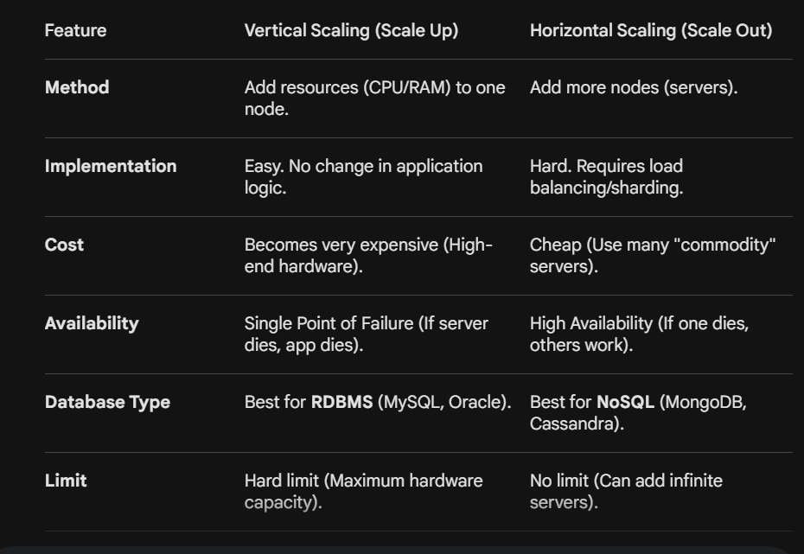
2. Horizontal Scaling (Scaling OUT)
The Philosophy: "Let’s buy more cars to carry the load." Horizontal scaling means adding more servers to your pool of resources.
- How it works: Instead of one giant server, you have 10 smaller servers. You split your data across them (a process called Sharding).
- Best for: Massive applications (Google, Netflix, Amazon) that need to handle millions of users.
- Limitations: It is much more complex. You have to figure out which server holds which data
Ques for drawback - If you are moving from 100GB TO 500GB what problem will occur ?? – when u scale up in a bigger server or a data , there is a downtime which is effected . so while scaling up the system will go down for the amount of time it will take to convert to 500 gb . that is the biggest drawback .
"How do you handle a database that has grown so large that even the most powerful server in the world can't process its queries?"
1. What is Sharding?
Sharding is a horizontal scaling strategy where you break up a single logical database into smaller, faster, and more manageable pieces called Shards.
- The Concept: Instead of one giant table with 1 billion rows, you have 10 tables with 100 million rows each, distributed across 10 different servers.
- The Crucial Detail: Each shard is a separate database, and the combined data of all shards represents the entire dataset.
2. Why do we need Sharding? (The "Pain Points")
- Storage Limits: A single machine has a finite amount of disk space.
- Memory/CPU Bottlenecks: If your index is too large to fit in RAM, performance drops 100x because the system has to read from the disk (Disk I/O).
- Network Bandwidth: A single server can only handle so many simultaneous connections.
3. How does it work? (The Shard Key)
To shard a database, you must pick a Shard Key. This is a column (like User_ID or Zip_Code) that determines which shard a specific row of data will live on.
Common Sharding Strategies:
- Key-Based (Hash) Sharding: You apply a hash function to the Shard Key (e.g., User_ID % 3).
  - Result: User 1 goes to Shard 1, User 2 to Shard 2, User 3 to Shard 0. This ensures data is spread evenly.
- Range-Based Sharding: Data is split based on ranges of a value.
  - Example: Users with names A-M go to Shard A; N-Z go to Shard B.
  - Risk: Can lead to "Hotspots" (e.g., if you have way more users starting with 'S' than 'X').
- Directory-Based Sharding: You maintain a lookup table that tracks which data is on which shard.

4. Real-World Scenario: The "Twitter" Problem
Imagine Twitter's "Tweets" table. If all tweets from everyone in the world were on one server, the server would explode.
- The Sharding Solution: You shard by User_ID.
- The Benefit: When you want to see Elon Musk's tweets, the application knows exactly which server to talk to. It doesn't have to search through billions of tweets from other users.
5. The "Price" of Sharding (The Disadvantages)
Interviewers love asking, "If sharding is so great, why don't we do it for every database?" You should answer with these "Complexities":
- Joins are nearly impossible: Joining a table on Shard A with a table on Shard B is extremely slow and complex. You usually have to "denormalize" your data to avoid this.
- Referential Integrity: It is very hard to enforce Foreign Key constraints across different physical servers.
- Resharding: If your shards become too big again, moving data from 3 shards to 5 shards (resharding) is a technical nightmare that often causes downtime.
- Single Point of Failure: If the "Router" (the piece of code that decides which shard to go to) breaks, the whole system is inaccessible.

6. Interview "Cracker" Questions
Q: "What is the difference between Partitioning and Sharding?"
Answer: Partitioning usually refers to "Vertical" or "Horizontal" splitting within the same server (like splitting a table by year). Sharding implies the data is physically moved to different servers/nodes.

Q: "What is a 'Hotspot' in sharding?"
Answer: "A hotspot occurs when one shard receives significantly more traffic than others. For example, if you shard by 'Country' and you have a celebrity in the US, the US shard might crash while the others are idle."
Q: "When should you NOT shard?"
Answer: "When your database is small enough to fit on a single large server (Vertical Scaling). Sharding introduces massive architectural complexity; you should only do it as a last resort when your data volume exceeds hardware limits."

KEYS
Think of a Key as a "Social Security Number" or a "Fingerprint" for a row.
1. Primary Key
The most important key. It uniquely identifies each record in a table.
- Rules:
  - It must be Unique (no two rows can have the same key).
  - It cannot be NULL (you can't have an "unknown" ID).
  - A table can have only one Primary Key.
- Scenario: In a Students table, Student_ID is the Primary Key. Even if two students are named "John Doe," their IDs will be different.
2. Candidate Key
A Candidate Key is a column (or set of columns) that could have been the Primary Key. They all have the potential to uniquely identify a row.
- The Relation: The Primary Key is simply the "winner" chosen by the DBA from the pool of Candidate Keys.
- Scenario: In an Employees table, both Employee_ID and Government_ID (SSN) are unique and non-null. Both are Candidate Keys. If you pick Employee_ID as the Primary Key, then Government_ID becomes an Alternate Key.
3. Alternate Key
Any Candidate Key that was not selected to be the Primary Key.
- Scenario: From the example above, if Employee_ID is the Primary Key, then Government_ID is the Alternate Key.
4. Foreign Key
A Foreign Key is a column in one table that points to the Primary Key of another table. It acts as a "bridge" to create a relationship.
- Purpose: To maintain Referential Integrity. It ensures you don't have "orphan" data (e.g., an Order for a Customer ID that doesn't exist).
- Scenario: * Table A (Customers) has Cust_ID (Primary Key).
  - Table B (Orders) has Order_ID (Primary Key) and Cust_ID (Foreign Key).
  - The Cust_ID in the Orders table tells us exactly which customer placed that order.
5. Composite Key
A key that consists of two or more columns that together uniquely identify a row. A single column isn't enough.
- Scenario: In a Class_Schedule table:
  - Room_Number alone isn't unique (many classes use it).
  - Time_Slot alone isn't unique (many rooms are used at 10 AM).
  - However, Room_Number + Time_Slot together is a Composite Key because only one class can be in a specific room at a specific time.

6. Super Key
A Super Key is a set of one or more columns that can uniquely identify a row.
- The Nuance: Unlike a Candidate Key, a Super Key can contain extra/redundant columns.
- Example: In our Students table, Student_ID is a Super Key. But {Student_ID, Student_Name} is also a Super Key, because the combination is still unique, even though the Name is unnecessary for uniqueness.
- Interview Tip: "Every Candidate Key is a Super Key, but not every Super Key is a Candidate Key (because Candidate Keys must be minimal)."

7. Surrogate Key
An artificial key added to a table when there is no "natural" unique column available.
- Scenario: If you have a table of Products where names might repeat and there are no barcodes, you create a column called Serial_No and let the database auto-increment it (1, 2, 3...). That is a Surrogate Key.

Q: "Can a Foreign Key be a Primary Key at the same time?"
- Answer: "Yes! This happens in a One-to-One relationship. For example, in a Users and User_Profiles table, the User_ID in the Profiles table can be both the Primary Key (to identify the profile) and a Foreign Key (pointing to the Users table)."
Q: "What is Referential Integrity?"
- Answer: "It is a rule enforced by Foreign Keys. it states that every Foreign Key value must either match a Primary Key value in the parent table or be NULL. It prevents the database from having 'broken links'."
Q: "What is the difference between a Unique Key and a Primary Key?"
- Answer: 1. A table can have multiple Unique Keys but only one Primary Key. 2. A Unique Key allows one NULL value, while a Primary Key allows zero NULL values.

RELATIONSHIPS

1. One-to-One (1:1)
Definition: A single record in Table A is related to exactly one record in Table B, and vice versa.
- Real-World Scenario: A User and their SSN/National ID. One person has one ID, and one ID belongs to only one person.
- How to Implement: You can put the Foreign Key in either table, but usually, it's added to the "Child" table with a UNIQUE constraint to ensure it doesn't repeat.
- Why use it? We use 1:1 to split a table that has too many columns or to isolate sensitive data (like putting "Passwords" in a separate 1:1 table for security).
2. One-to-Many (1:N)
Definition: A single record in Table A can be related to multiple records in Table B, but a record in Table B is related to only one record in Table A.
- Real-World Scenario: Department and Employees. One Department (Sales) can have many Employees, but each Employee belongs to only one Department.
- How to Implement: The Primary Key of the "One" side (Department_ID) is added as a Foreign Key to the "Many" side (Employees table).
- Note: This is the most common relationship in database design.
3. Many-to-Many (M:N)
Definition: Multiple records in Table A can be related to multiple records in Table B.
- Real-World Scenario: Students and Courses. A student can enroll in many courses, and a course can have many students.
- How to Implement (The Interview "Must-Know"): You cannot implement M:N directly between two tables. You must use a third table called a Junction Table (or Associative/Bridge Table).
The Junction Table contains the Primary Keys of both tables as Foreign Keys.
- Example: A table Enrollments with Student_ID and Course_ID.

4. Self-Referencing Relationship (Unary)
Definition: A table has a relationship with itself.
- Real-World Scenario: An Employee table where one column is Manager_ID. Since the manager is also an employee, the Manager_ID points back to the Employee_ID in the same table.
- Interview Question: "How do you find an employee's manager name?"
  - Answer: "By using a Self-Join on the table."

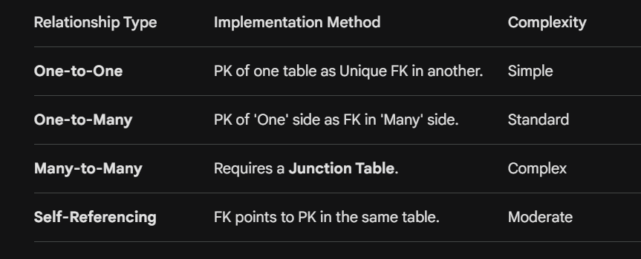
RELATIONSHIP QUESTIONS
Q1: "Why can't we just store multiple Course IDs in a single 'Student' row for a Many-to-Many relationship?"
Answer: "That would violate the 1st Normal Form (1NF), which requires atomic values. It makes searching, updating, and deleting courses nearly impossible and ruins performance."

Q2: "What is a 'Participation Constraint'?"
Answer: "It defines whether all records in a table must participate in a relationship.
- Total Participation: Every student must be assigned to a department.
- Partial Participation: Not every employee has to be a manager."

Q3: "What is a Recursive Relationship?"
Answer: "It's another name for a Self-Referencing relationship, where an entity is related to itself (like a 'Prerequisite' course pointing to another 'Course')."

Data Abstraction
It not just as a definition, but as a design philosophy that prevents a system from breaking every time a change is made.
1. Physical Level (The "How")

This is the Internal Schema. It is the most complex and lowest level of abstraction.
- Detailed View: It deals with how data is actually stored on the physical hard drive. It defines the record formats, the order of bytes, and the Access Paths (like B-Trees or Hashing) used to retrieve data.
- The Scenario: If you decide to compress your data to save space or move it from a local disk to a cloud-based Blob storage, you are making changes at this level.
- Key Question: "Where is the data stored?"

2. Conceptual Level (The "What")

This is the Logical Schema. It describes the structure of the entire database for the community of users.
- Detailed View: This level hides the "blocks and bits" of the physical level and focuses on Entities, Attributes, and Relationships. It defines what tables exist, what columns they have, and the "rules" (constraints) like "Salary cannot be negative."
- The Scenario: If you are designing a University Database, at this level you decide that a Student table will have ID, Name, and Major, and that it must be linked to a Department table.
- Key Question: "What data is stored and how are the tables related?"

3. External Level (The "Perspective")

This is the View Schema. It is the highest level and is closest to the users.
- Detailed View: A database has only one Conceptual and one Physical schema, but it can have multiple External schemas (Views). Each view is tailored for a specific user.
- The Scenario: * The Student View: Can see their own Grades and Attendance.
  - The Registrar View: Can see Fees Paid, Address, and Grades for all students.
  - The Payroll View: Can see the Salary of professors, which students aren't even allowed to know exists.
- Key Question: "What part of the data does this specific user need to see?"

Data Independence (The "Why")
This is the most critical part of the concept. The separation of these levels allows for Data Independence.

A. Physical Data Independence
- Definition: The ability to change the Physical Schema without affecting the Conceptual Schema.
- Example: You can switch from an Oracle database to a PostgreSQL database (Physical change), and as long as your table names and columns stay the same (Conceptual level), your application code won't break.

B. Logical Data Independence
- Definition: The ability to change the Conceptual Schema without affecting the External Views or application programs.
- Example: If you split an Employee table into Emp_Personal_Info and Emp_Job_Info (Conceptual change), you can create a View that joins them back together. To the user, it still looks like one single table, so their dashboard doesn't crash.

- "What is 'Mapping' in 3-schema architecture?"
  - Answer: Mapping is the process of transforming requests and results between the levels. For example, if a user asks for a "Student Name" (External), the DBMS maps that to the Students table (Conceptual), which is then mapped to a specific block on the hard drive (Physical).
- "Why is Logical Data Independence harder to achieve than Physical?"
  - Answer: Because changing the logical structure (like adding/deleting columns or splitting tables) often forces a change in the application logic. Physical changes (like adding a new hard drive) are usually handled entirely by the DBMS itself.
- "Can we have more than three levels?"
  - Answer: Technically, the ANSI-SPARC model defines these three, but modern applications often add an "Application Layer" or "API Layer" above the External level for even further abstraction.
INDEXING
The database is slow; how do you fix it?"

Think of an index in a database exactly like the Index at the back of a 1,000-page textbook. Without it, if you wanted to find the definition of "Atomicity," you would have to scan every single page (this is called a Full Table Scan). With an index, you look up "Atomicity," find page 452, and flip directly there.

1. How does Indexing work?
An Index is a small, separate data structure (usually a B-Tree or Hash Table) that stores the values of a specific column and a pointer to the physical location of the row on the disk.
- Search without Index: Complexity $O(N)$ (Linear Search).
- Search with Index: Complexity $O(\log N)$ (Binary Search via B-Tree).

2. Types of Indexing
A. Clustered Index
- Definition: It defines the physical order in which data is stored in the table.
- Rule: A table can have only one clustered index (because you can't store rows in two physical orders at once).
- Example: In most systems, the Primary Key automatically creates a clustered index. It's like a Dictionary where words are physically sorted alphabetically.

B. Non-Clustered Index
- Definition: A separate structure from the data rows. It contains the index key and a pointer to the row containing the key value.
- Rule: You can have multiple non-clustered indexes on a single table.
- Example: Like the index at the back of a book. The "content" (chapters) is in one order, but the "index" is a separate list that points to the page numbers.

C. Unique vs. Non-Unique Index
- Unique: Ensures that the column(s) indexed do not have duplicate values.
- Non-Unique: Used solely for performance, allowing duplicate values in the column.

3. The "Cost" of Indexing (The Interview Trap)
Interviewers love to ask: "Why don't we just index every single column?"
The Answer: Because Indexing is a trade-off between Read Speed and Write Speed.
- Storage: Every index takes up additional disk space.
- Slower Inserts/Updates/Deletes: Every time you add a row, the DBMS must also update all the corresponding indexes. If you have 10 indexes, one INSERT command actually triggers 11 write operations.
Rule of Thumb: Index columns that are frequently used in WHERE, JOIN, and ORDER BY clauses, but avoid indexing columns with low "cardinality" (e.g., a "Gender" column with only two values).

4. Real-World Scenarios
Scenario A: The E-commerce Search
When you search for a product by Name, the database uses a Non-Clustered Index on the Product_Name column to find the ID, then fetches the details. Without this index, searching through 10 million products would take seconds; with it, it takes milliseconds.

Scenario B: Range Queries
If you ask for SELECT * FROM Orders WHERE Date BETWEEN '2023-01-01' AND '2023-01-31', a Clustered Index on the Date column is perfect because the data is physically stored together, making the "range scan" incredibly fast.

5. Critical Interview Questions
Q: "What is a 'Covering Index'?"
- Answer: "A covering index is a non-clustered index that includes all the columns requested in a query. Since the index itself has all the data, the DBMS doesn't even need to look at the actual table, making the query lightning fast."

Q: "What is the difference between a B-Tree and a Hash Index?"
- Answer: B-Tree supports range queries (e.g., Age > 20). Hash Indexes are only good for exact matches (e.g., ID = 105) because hashes don't preserve order.

Q: "What is 'Index Seeking' vs 'Index Scanning'?"
- Answer: Seeking is fast; it means the DBMS used the index to jump straight to the data. Scanning is slower; it means the DBMS had to look through the entire index because the query wasn't specific enough.

1. What is DDL?
DDL (Data Definition Language) is a subset of SQL used to define, modify, and manage the structure (schema) of database objects such as tables, indexes, and users.
- Focus: It deals with the metadata (data about data), not the actual data rows.
- Auto-Commit: In most RDBMS (like Oracle or MySQL), DDL commands are auto-committed. This means once you run them, they are saved permanently and cannot be rolled back easily.

2. The Core DDL Commands
You should memorize these five commands and their specific "Real-World" roles:
A. CREATE
Used to create new objects like databases, tables, or views.
- Scenario: You are launching a new "Orders" feature and need a place to store data.
- Syntax Example:
SQL
CREATE TABLE Students (ID INT PRIMARY KEY, Name VARCHAR(50));
B. ALTER
Used to modify the structure of an existing object without destroying it.
- Scenario: Your boss tells you that from now on, you also need to store "Date of Birth" for every student.
- Action: You add a column using ALTER.
C. DROP
Used to delete an entire object (the structure AND the data) from the database.
- Scenario: The "Old_Promotions" table is no longer needed.
- Warning: This is destructive. The table is gone forever.
D. TRUNCATE
Used to remove all records from a table, but it keeps the structure (the columns) intact.
- Scenario: You want to clear all test data from a table before moving it to production, but you want to keep the table itself.
- Key Difference: It is much faster than DELETE because it doesn't scan every row.
E. RENAME
Used to change the name of a database object.
- Scenario: Changing a table named Emp to Employees for better clarity.

4. Why DDL is important for "Schema Evolution"

In the industry, we call changes to the database structure Schema Evolution. As an engineer, you must handle DDL carefully because running an ALTER TABLE on a table with 50 million rows can "lock" the table, preventing users from using the app for minutes or hours.
Interview Pro-Tip: If asked how to perform DDL on a massive live table, mention "Blue-Green Deployment" or "Online Schema Change tools" like gh-ost. It shows you have real-world perspective!

In your interview, while DDL is about the "skeleton" of the database, DML (Data Manipulation Language) is about the "meat." This is the language you will use 95% of the time as a developer to interact with the data stored inside those tables.

1. What is DML?
DML is a subset of SQL used to manage and manipulate the data within existing database objects. It allows you to add, modify, and delete the actual records (rows).
- Focus: It deals with the rows/tuples, not the table structure.
- Manual-Commit: Unlike DDL, DML commands are typically not auto-committed in many systems. This means you can "undo" your changes using a ROLLBACK command as long as you haven't "saved" them with a COMMIT.

2. The Core DML Commands
There are three primary DML commands you must know inside out:

A. INSERT
Used to add new rows of data into a table.
- Scenario: A new user signs up for your app; you need to store their details.
- Syntax: INSERT INTO Students (ID, Name) VALUES (101, 'Aryan');

B. UPDATE
Used to modify existing data within a table. This is almost always used with a WHERE clause.
- Scenario: A customer changes their shipping address.
- Warning: If you forget the WHERE clause, you will update every single row in the table (a classic developer nightmare).
- Syntax: UPDATE Students SET Name = 'Aryan Sharma' WHERE ID = 101;

C. DELETE
Used to remove specific rows from a table.
- Scenario: A user deactivates their account, and you need to remove their data.
- Note: Like UPDATE, this requires a WHERE clause to avoid wiping the entire table.
- Syntax: DELETE FROM Students WHERE ID = 101;

3. DML vs. DDL: The Interview Comparison
Interviewers love to see if you can distinguish between the structure and the content.
Feature | DDL (Definition) | DML (Manipulation)
Purpose | To define/modify the schema. | To add/modify/delete data.
Effect | Affects the whole table/structure. | Affects specific rows.
Commands | CREATE, ALTER, DROP, TRUNCATE. | INSERT, UPDATE, DELETE.
Commit | Auto-committed (Permanent). | Not auto-committed (Can be rolled back).
Analogy | Designing the columns in an Excel sheet. | Typing data into the cells.

4. Advanced "Pro" Interview Questions
Q: "Why is the SELECT statement sometimes called DML and sometimes DQL?"
- Answer: "Technically, SELECT retrieves data without 'manipulating' it, which is why many categorize it as DQL (Data Query Language). However, because it is the most frequent command used alongside INSERT/UPDATE, some older textbooks group it under DML."

Q: "What happens if a DML operation violates a Constraint?"
- Answer: "The DBMS will reject the operation. For example, if I try to INSERT a row with a duplicate ID into a Primary Key column, the DML statement will fail to maintain Entity Integrity."
Q: "How does DML relate to the ACID properties?"
- Answer: "DML is the level where Atomicity and Isolation are most visible. If a DML transaction involving multiple UPDATE statements fails halfway, the system uses TCL (COMMIT/ROLLBACK) to ensure the database stays consistent."

- Real-World Scenario: The "Bank Balance" Update
- Imagine a bank transfer.
- You use DML (UPDATE) to subtract $100 from Account A.
- You use DML (UPDATE) to add $100 to Account B.
- If the second DML fails, the first one is rolled back. This shows why DML is not auto-committed—it gives us a safety net.

1. What is Normalization?
Normalization is a systematic process of organizing data in a database to achieve two main goals:
- Eliminate Redundant (Duplicate) Data: Why store a customer's address 10 times if they make 10 orders?
- Ensure Data Dependency: Data should be stored logically (only related data should be in the same table).
The Real-World "Why": Imagine a library system where every time a student borrows a book, you re-type the student's name, phone number, and address. If the student changes their phone number, you’d have to find every single row they ever created and update it. If you miss one, your data is inconsistent. This is called an Update Anomaly.

2. Types of Normalization (Normal Forms)
1st Normal Form (1NF) - "Atomic Values"
The Rule: A table is in 1NF if every column contains atomic (indivisible) values and there are no repeating groups.
- The Problem: You have a Student table where the Courses column contains "Math, Science, Art".
- The Fix: You cannot have multiple values in one cell. You must split them so each row has only one course.
- Scenario: If you try to search for students taking "Math," the database has to do complex string matching if it's not in 1NF. In 1NF, it's a simple query.
2nd Normal Form (2NF) - "No Partial Dependency"
The Rule: Must be in 1NF AND all non-key attributes must be fully functionally dependent on the primary key. This applies to tables with Composite Keys.
- The Problem: Consider a table Project_Assignments with a composite key (Employee_ID, Project_ID). If the table also contains Project_Name, that is a problem. Why? Because Project_Name only depends on Project_ID, not the Employee_ID.
- The Fix: Move Project_ID and Project_Name to a separate Projects table.
- Scenario: If 50 employees work on "Project Apollo," and you want to rename it to "Project Artemis," in a non-2NF table, you change 50 rows. In 2NF, you change one row in the Projects table.

3rd Normal Form (3NF) - "No Transitive Dependency"
The Rule: Must be in 2NF AND no non-key attribute should depend on another non-key attribute.
- The Problem: An Employee table has Emp_ID (PK), Dept_ID, and Dept_Name. Here, Dept_Name depends on Dept_ID. But Dept_ID is not the Primary Key. This is a Transitive Dependency.
- The Fix: Move Dept_ID and Dept_Name to a separate Departments table.
- Scenario: If you delete the last employee in the "Marketing" department, you accidentally delete the existence of the "Marketing" department itself from your records. This is a Deletion Anomaly.

Boyce-Codd Normal Form (BCNF) - "The Strong 3NF"
The Rule: For every functional dependency $X \rightarrow Y$, $X$ must be a Super Key.
- The Problem: This happens when a table has multiple overlapping Candidate Keys. It’s a rarer, stricter version of 3NF used for highly complex systems.
- Simple Summary: If 3NF is about "The Key, the Whole Key," BCNF ensures there are no "backdoor" dependencies between parts of different candidate keys.
3. Summary of Anomalies (The "Interview Trap")
Interviewers often ask, "What happens if we don't normalize?" Mention these three:
- Insertion Anomaly: You can't insert a new department because you haven't hired any employees for it yet (if they are in the same table).
- Update Anomaly: You update a price in one row but forget the other 5 rows where that product appears.
- Deletion Anomaly: You delete a student's enrollment and accidentally wipe out the entire course's information from the DB.
4. Real-World Scenario: Designing "Amazon"
- Step 1 (Unnormalized): One giant table with Customer_Name, Address, Product_Name, Price, Order_Date.
- Step 2 (1NF): Ensure a user can't buy two products in one "cell." Every product gets its own row.
- Step 3 (2NF): Move Product_Price to a Products table because price depends on the Product, not the Customer who bought it.
- Step 4 (3NF): Move City and Zip_Code to a separate table because City depends on the Zip_Code, not directly on the Customer_ID.

5. The "Pro" Question: "Is more normalization always better?"
The Answer: "No. Normalization improves Data Integrity, but it requires more Joins. In high-speed systems (like a social media feed), we sometimes Denormalize (purposefully add redundancy) to make Read queries faster. It's a trade-off between Consistency and Performance."

In a high-level placement interview, Denormalization is the "Real World" follow-up to Normalization. While Normalization is about being theoretically perfect, Denormalization is about being practically fast.

1. What is Denormalization?
Denormalization is the strategic process of adding redundant data to a previously normalized database to improve read performance.
It is NOT "failing to normalize." It is a conscious decision made after normalization to reduce the number of complex "JOINS" that the database engine has to perform.
The Golden Rule: You Normalize for Write efficiency (Integrity). You Denormalize for Read efficiency (Performance).
2. Why do we need it? (The "Join" Problem)
In a fully normalized database (3NF), data is split into many small tables. To get a single "Invoice," the database might have to join 5 tables: Users, Orders, Order_Items, Products, and Discounts.
The Problem: Joins are computationally expensive. On a website with millions of users, joining 5 tables for every single page load can make the site feel sluggish.
The Solution: We "fold" some data back together. We might store the Product_Name directly in the Order_Items table, even though it technically belongs in the Products table.

3. Real-World Scenarios
Scenario A: E-commerce Order History
Normalized: To show your orders, the app joins Orders and Products to get the price of the item at the time you bought it.
Denormalized: We store the Price_at_Purchase directly in the Orders table.
Why? Even if the product price changes next month, your receipt must show what you paid. Also, it’s faster to load your history.

Scenario B: Social Media "Likes"
Normalized: A Likes table tracks every single user who liked a post. To show the count, the DB runs SELECT COUNT(*) every time someone views the post.
Denormalized: We add a Like_Count column to the Posts table.
Why? Running a count on 1 million rows for every view is a system killer. It’s better to just update a single number.

4. Pros and Cons
Feature | Pros (The Good) | Cons (The Bad)
Performance | Faster Data Retrieval (Read). | Slower Data Updates (Write).
Complexity | Simpler Queries (fewer JOINS). | Complex logic to keep redundant data in sync.
Storage | Uses more disk space (Redundancy).
Integrity | Risk of Data Inconsistency.

5. How to handle the "Inconsistency" risk?
If you store the User_Name in both the Users table and the Comments table (Denormalization), what happens when the user changes their name?
In an interview, mention these two solutions to show you're an expert:
Application Logic: The code is written to update both tables simultaneously.
Database Triggers: A trigger is set so that whenever Users.name changes, the DB automatically updates Comments.user_name.

6. Interview "Cracker" Questions
Q: "When should we decide to denormalise?
Answer: "Only when performance bottlenecks are identified. We should always start with a normalised design. If 'Read' queries are taking too long due to excessive JOINS, we selectively denormalise the most frequently accessed data."
Q: "Does Denormalisation mean we ignore ACID?"
Answer: "No. We still want Atomicity and Durability. However, we are sacrificing a bit of 'Ease of Consistency' to gain 'Availability' and 'Speed.' It makes the developer's job harder because they must ensure all redundant copies of data stay the same.".
Q: "Is NoSQL inherently denormalised?"
Answer: "Yes! NoSQL databases like MongoDB encourage 'Document Embedding' (putting all related data in one record), which is essentially a denormalised way of storing data for maximum speed."
Summary for the Interviewer
"Sir/Ma'am, Normalisation is used to reduce redundancy and maintain integrity, which is great for Write-heavy systems like Banking. Denormalization is used to increase speed by adding controlled redundancy, which is essential for Read-heavy systems like Social Media or Dashboards."

In a DBMS interview, Functional Dependency (FD) is the secret sauce behind Normalization. It is the formal way of describing the relationship between attributes (columns) in a table.
Think of it as a "Mathematical Link" or a "Remote Control": if you press a specific button (the Key), you always get the same channel (the Value).

1. What is Functional Dependency?
A functional dependency $X \to Y$ (read as "X functionally determines Y") exists when the value of $X$ uniquely determines the value of $Y$.
If two rows have the same value for $X$, they must have the same value for $Y$.
- X (Left side): The Determinant.
- Y (Right side): The Dependent.
The Real-World Scenario: The Student ID
In a University database: Student_ID $\to$ Student_Name.
- If I tell you the ID is 101, you can tell me the name is "Rahul."
- It is impossible for ID 101 to be "Rahul" in one row and "Sneha" in another.
- Therefore, Student_Name is Functionally Dependent on Student_ID.

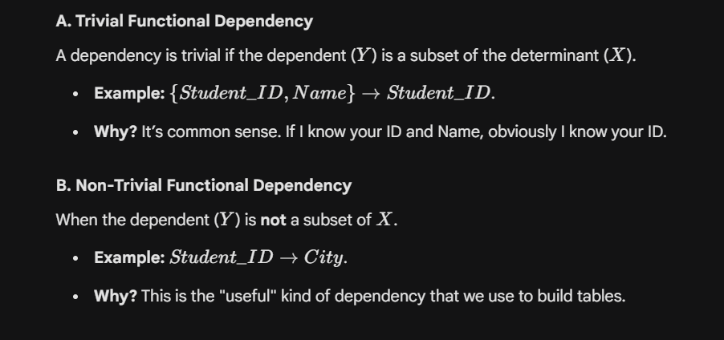
2. Types of Functional Dependencies
Interviewers often ask for these specific types to see if you understand the nuances.

4. Why is FD important for the Interview?
You should summarize your answer by linking it to Normalization:
"Sir/Ma'am, Functional Dependency is the foundation of database design. We use it to identify 'bad' relationships in a table—like Partial or Transitive dependencies. By finding these FDs, we can split a large, messy table into smaller, normalized ones, ensuring data integrity and reducing redundancy."

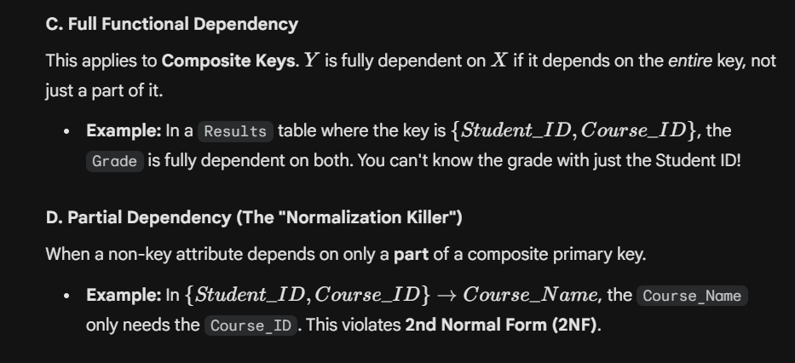
Common Interview Question:
"Can two different people have the same name in a table where ID $\to$ Name?"
Answer: "Yes! Functional Dependency only works one way. $X \to Y$ does not mean $Y \to X$. Multiple IDs can point to the name 'Rahul,' but one ID cannot point to two different names."
The E-R Model (Entity-Relationship Model) is the "Blueprint" phase of database design. In an interview, think of it as the conceptual map you draw on a whiteboard before you ever write a single line of SQL code.
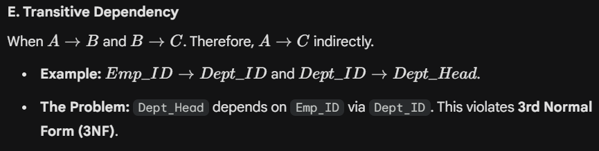
It describes the structure of a database by looking at the Entities (things), their Attributes (properties), and the Relationships between them.

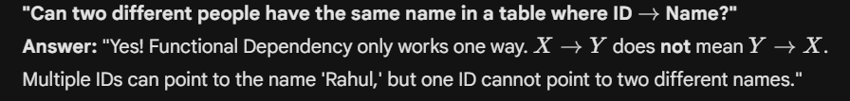

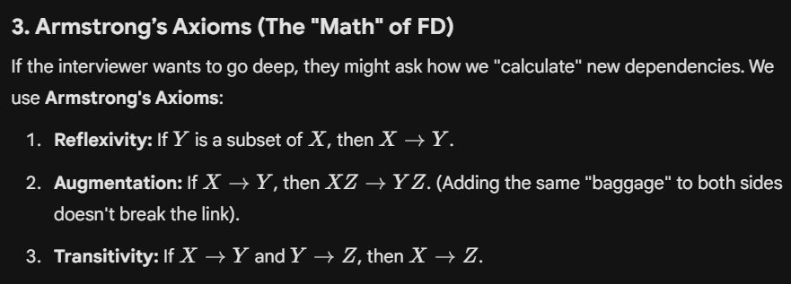

ER MODEL

The E-R Model (Entity-Relationship Model) is the "Blueprint" phase of database design. In an interview, think of it as the conceptual map you draw on a whiteboard before you ever write a single line of SQL code.
It describes the structure of a database by looking at the Entities (things), their Attributes (properties), and the Relationships between them.

1. Core Components of an ER Model
A. Entity
An Entity is a real-world "object" or "thing" that is distinguishable from others.
- Strong Entity: Can exist independently (e.g., a Student).
- Weak Entity: Cannot be uniquely identified by its own attributes and depends on a "parent" entity (e.g., Dependent or Nominee of an employee).

B. Attributes
These are the properties that describe an entity.
- Simple: Indivisible (e.g., Age).
- Composite: Can be divided into sub-parts (e.g., Name into First_Name and Last_Name).
- Single-valued: Only one value (e.g., Date_of_Birth).
- Multi-valued: Can have multiple values (e.g., Phone_Numbers).
- Derived: Calculated from other attributes (e.g., Age derived from DOB).

C. Relationship
This defines how entities are connected to each other (e.g., a Student Enrolls in a Course). Relationships have Cardinality (1:1, 1:N, M:N).

2. ER Diagram Symbols (The "Language")
Shape | Meaning
Rectangle | Entity
Double Rectangle | Weak Entity
Ellipse (Oval) | Attribute
Underlined Ellipse | Primary Key (Key Attribute)
Dashed Ellipse | Derived Attribute
Double Ellipse | Multi-valued Attribute
Diamond | Relationship

3. Real-World Scenario: Designing "Hospital Management"
If an interviewer asks you to draw an ER model for a hospital:
- Identify Entities: Patient, Doctor, Room, Medicine.
- Define Attributes: Patient has Patient_ID, Name, Blood_Group.
- Establish Relationships: * A Doctor Treats a Patient (1:N or M:N).
  - A Patient Occupies a Room (1:1).
  - A Doctor Prescribes Medicine (M:N).

4. Mapping ER Model to Tables (Relational Schema)
This is a very common follow-up: "How do you convert an ER diagram into actual tables?"
- Rule 1: Each Strong Entity becomes a Table.
- Rule 2: Multi-valued attributes become a separate table (e.g., a Student_Phones table) to stay in 1NF.
- Rule 3: Many-to-Many relationships become a new "Junction Table" (as we discussed in the Relationships section).
- Rule 4: Derived attributes are usually NOT stored in tables; they are calculated in queries to save space.

5. Interview Questions & "Pro" Answers
Q: "What is the difference between a 'Key' and an 'Attribute'?"
- Answer: "An attribute is any property of an entity. A Key is a special attribute (or set of attributes) used to uniquely identify an entity instance within an entity set."
Q: "When do we use a Weak Entity?"
- Answer: "We use a weak entity when an object doesn't have a natural primary key. For example, in a hotel, a 'Room' is often a weak entity because 'Room 101' only makes sense when attached to a specific 'Hotel_ID'."
Q: "What is Participation Constraint in ER models?"
- Answer: "It defines if every entity in a set must participate in a relationship.
  - Total Participation (Double Line): Every Employee must work for a Department.
  - Partial Participation (Single Line): Not every Employee must be a Manager."

Why ER Modeling is "King"
In the industry, we use ER models to get Stakeholder Approval. You show the diagram to a business manager (who doesn't know SQL) to confirm the logic is correct before you spend weeks building the database.

In a DBMS interview, Conflict Serializability is the "level 2" of Transaction Management. It is the technical way a DBMS ensures that even when multiple users are working at once (Concurrency), the result is as safe as if they were working one after another (Serial).

1. The Core Concept
A schedule is Conflict Serializable if it can be transformed into a Serial Schedule (one transaction after another) by swapping non-conflicting, adjacent operations.
What is a "Conflict"?
Two operations are said to be in conflict if they satisfy all three of these conditions:
- They belong to different transactions.
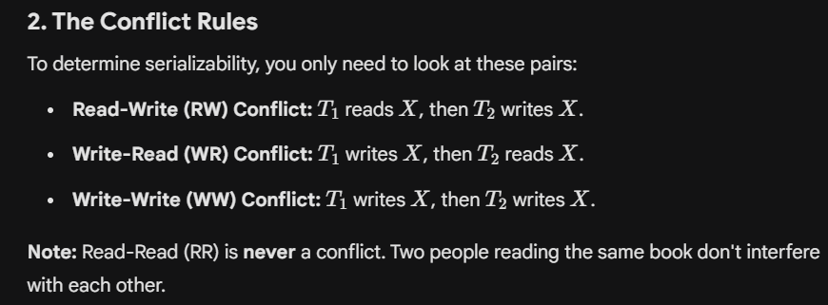
- They access the same data item (e.g., both are touching Account A).
- At least one of them is a WRITE operation.

2. The Conflict Rules
To determine serializability, you only need to look at these pairs:
- Read-Write (RW) Conflict: $T_1$ reads $X$, then $T_2$ writes $X$.
- Write-Read (WR) Conflict: $T_1$ writes $X$, then $T_2$ reads $X$.
- Write-Write (WW) Conflict: $T_1$ writes $X$, then $T_2$ writes $X$.
Note: Read-Read (RR) is never a conflict. Two people reading the same book don't interfere with each other.

3. How to check for Conflict Serializability?
In an interview, you might be given a schedule and asked if it's serializable. You solve this using a Precedence Graph.
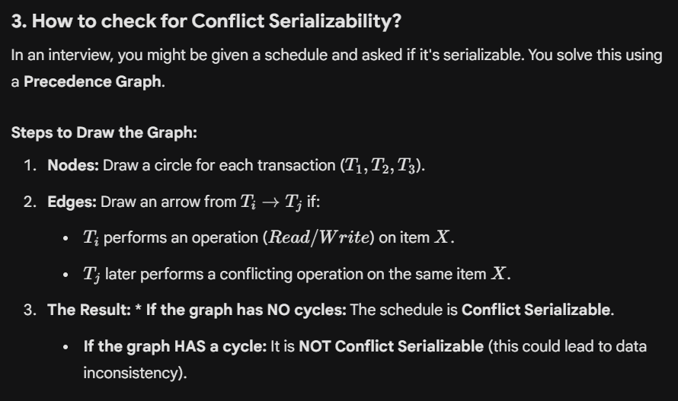
Steps to Draw the Graph:
- Nodes: Draw a circle for each transaction ($T_1, T_2, T_3$).
- Edges: Draw an arrow from $T_i \to T_j$ if:
  - $T_i$ performs an operation ($Read/Write$) on item $X$.
  - $T_j$ later performs a conflicting operation on the same item $X$.
- The Result: * If the graph has NO cycles: The schedule is Conflict Serializable.
  - If the graph HAS a cycle: It is NOT Conflict Serializable (this could lead to data inconsistency).

4. Real-World Scenario: The Double Update
Imagine two people, A and B, trying to update the price of the same product.
- $T_1$ (User A): Reads price ($100) $\to$ Adds $10 $\to$ Writes ($110).
- $T_2$ (User B): Reads price ($100) $\to$ Multiplies by 2 $\to$ Writes ($200).
If $T_2$ reads the price before $T_1$ writes it, they are in conflict. If the final database shows $200, User A’s $10 addition is "lost." A Conflict Serializable scheduler would detect this and force $T_2$ to wait until $T_1$ is finished, ensuring the final price is either $220 or $210.
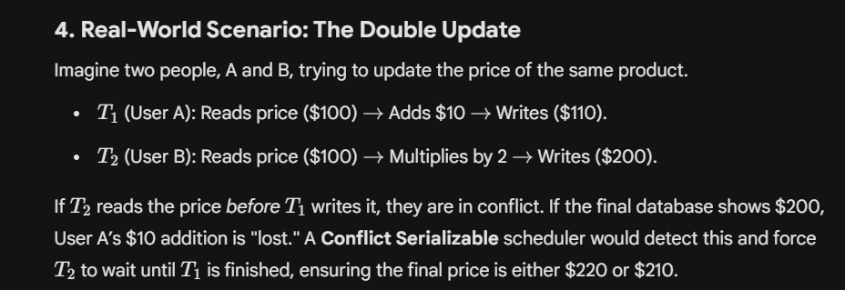
5. View Serializability (The "Brother" Concept)
The interviewer might ask: "Is every serializable schedule conflict serializable?"
Answer: "No. There is a broader category called View Serializability. Every Conflict Serializable schedule is View Serializable, but not vice versa. View serializability is harder to check (it's NP-Complete) and handles 'Blind Writes' (writing without reading first)."

6. Interview Questions & "Pro" Answers

Q: "Why do we prefer Conflict Serializability over View Serializability in real systems?"
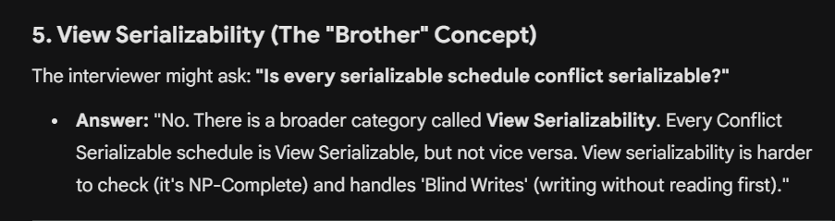
Answer: "Conflict serializability can be checked efficiently using a Precedence Graph ($O(n^2)$ complexity). View serializability is much more computationally expensive to verify, making it impractical for high-speed database engines."

Q: "What happens if a schedule is not Conflict Serializable?"
Answer: "It may lead to anomalies like the Lost Update Problem, Inconsistent Analysis, or Uncommitted Dependency. The DBMS will usually use a protocol like Two-Phase Locking (2PL) to prevent such schedules from occurring."

Q: "What is the 'Serializability Order'?"
Answer: "If the graph is acyclic, you can find the order using Topological Sort. For example, if the graph is $T_2 \to T_1 \to T_3$, the equivalent serial order is $T_2$ then $T_1$ then $T_3$."

Concurrency Control

1. DEFINITION
Concurrency Control is the process of managing simultaneous operations on a database so that they do not conflict with each other.
Purpose: To maintain Data Integrity and Consistency when multiple transactions are executed at the same time.
Goal: To ensure that the interleaved execution of transactions results in a state that is equivalent to a Serial Schedule (one-by-one execution).

2. THE THREE MAIN PROBLEMS (WHY WE NEED CCP)

If we don't use these protocols, the following anomalies occur:
Lost Update Problem: Two transactions read the same data and update it; the second update overwrites the first.
Dirty Read Problem: A transaction reads data that has been modified by another transaction but not yet committed.
Unrepeatable Read: A transaction reads the same data item twice and finds different values because another transaction modified it in between.

3. TYPES OF PROTOCOLS

A. Lock-Based Protocols
Transactions must acquire a "Lock" before accessing data.
Shared Lock (S): Used for Reading. Multiple transactions can hold an S-lock on the same item.
Exclusive Lock (X): Used for Writing. Only one transaction can hold an X-lock. No other transaction can read or write that item.

B. Two-Phase Locking (2PL)
This is the most common protocol to ensure Serializability. It has two phases:
Growing Phase: Transaction may obtain locks but cannot release any.
Shrinking Phase: Transaction may release locks but cannot obtain any new ones.
Strict 2PL: A variation where the transaction holds all Exclusive Locks until it commits/aborts. This prevents Cascading Rollbacks.

C. Timestamp-Based Protocols
Instead of locks, each transaction gets a unique Timestamp ($TS$) when it starts.
Logic: If $T_1$ is older than $T_2$, the system ensures $T_1$'s operations are processed as if it happened before $T_2$.
Conflict Rule: If a younger transaction has already updated a value that an older transaction now wants to read/write, the older transaction is rolled back and restarted with a new timestamp.
Benefit: It is Deadlock-Free.

D. Validation-Based (Optimistic) Protocols
Assumes that conflicts are rare.
Read Phase: Transaction executes using local copies of data.
Validation Phase: System checks for conflicts with other transactions.
Write Phase: If no conflict, changes are made permanent.

4. DEADLOCK HANDLING IN CCP
Since Lock-based protocols can lead to Deadlocks (where $T_1$ waits for $T_2$ and $T_2$ waits for $T_1$), CCP includes:
Deadlock Prevention: * Wait-Die: Older waits for younger; younger dies if it asks for older's lock. Wound-Wait: Older kills (wounds) younger; younger waits for older's lock.
Deadlock Detection: The DBMS maintains a Wait-For-Graph. If a cycle is detected, one transaction is rolled back (the "Victim").

5. TOP INTERVIEW QUESTIONS & ANSWERS
Q1: What is the difference between Lock-based and Timestamp-based protocols?
Answer: Lock-based protocols manage concurrency by making transactions wait for resources, which can lead to deadlocks. Timestamp-based protocols manage concurrency by ordering transactions based on their entry time and restarting them if a conflict occurs, making them deadlock-free but potentially causing starvation.

Q2: Does 2PL guarantee freedom from Deadlocks?
Answer: No. Basic 2PL ensures Serializability, but it does not prevent deadlocks. To handle deadlocks, we need additional mechanisms like Deadlock Detection or Prevention.

Q3: What is "Starvation" in CCP?
Answer: Starvation occurs when a particular transaction is repeatedly rolled back or kept waiting indefinitely because other transactions are always given priority. This is usually solved by using a "First-Come-First-Served" (FCFS) approach for locks or timestamps.

Q4: When should we use Optimistic Concurrency Control?
Answer: It should be used in environments with Low Contention (where transactions rarely touch the same data). It is very efficient because it avoids the overhead of managing locks.

THE ENTITY HIERARCHY IN DBMS

1. ENTITY

An Entity is a "thing" or "object" in the real world that is distinguishable from all other objects. It can be a person, place, object, or even a concept.
Example: A specific student named "Rahul" with ID 101.
Physical Entity: A car, a house, an employee.
Conceptual Entity: A bank account, a course, a job position.

2. ENTITY TYPE
An Entity Type is a collection of entities that share the same attributes. In the physical database, this usually becomes the Table Name.
Example: STUDENT is an Entity Type. It defines that every student will have a Name, Age, and ID.
Analogy: If Entity is a "variable value," Entity Type is the "Class" or "Data Type."

3. ENTITY SET
An Entity Set is a collection (set) of all entities of a particular entity type at any given point in time.
Example: All the students currently enrolled in your University form the STUDENT Entity Set.
Visualizing it: * Entity Type: The "Header" of the table.
Entity: A single "Row" in the table.
Entity Set: The "Entire Table" populated with data.

4. WEAK ENTITY SET
A Weak Entity Set is an entity set that does not have a Primary Key of its own. It cannot be uniquely identified without being linked to a "Parent" or "Owner" entity set.
Characteristics:
- Dependency: It has a Total Participation constraint with the owner entity (it cannot exist without the owner).
- Identifying Relationship: The relationship linking the weak entity to its owner is called an Identifying Relationship.
- Discriminator (Partial Key): Instead of a Primary Key, it has a "Discriminator"—an attribute that uniquely identifies a weak entity within the scope of its owner.
Real-World Scenario:
Owner Entity: EMPLOYEE (Primary Key: Emp_ID).
Weak Entity: DEPENDENT (Attributes: Name, BirthDate).
The Logic: If two employees have a child named "Aarav," you can't tell them apart using just the name. You need the Emp_ID (Owner's Key) + Name (Discriminator) to uniquely identify a specific dependent.

5. COMPARISON FOR THE INTERVIEWER
Feature | Strong Entity Set | Weak Entity Set
Primary Key | Has its own Primary Key. | Has a Discriminator (Partial Key).
Existence | Independent existence. | Dependent on the Owner Entity.
ER Symbol | Single Rectangle. | Double Rectangle.
Participation | Can be Partial or Total. | Always Total Participation.
Relationship | Represented by a Diamond. | Double Diamond (Identifying Relationship).

6. TOP INTERVIEW QUESTIONS
Q1: "Can a Weak Entity have a Primary Key?"
- Answer: No. By definition, a Weak Entity lacks a primary key. However, we can create a "Composite Primary Key" for it by combining the Primary Key of the Owner Entity and the Weak Entity's Discriminator.
Q2: "What happens to a Weak Entity if the Owner Entity is deleted?"
- Answer: Due to Total Participation, if the Owner Entity is deleted, all associated Weak Entities are also deleted. This is typically implemented using ON DELETE CASCADE in SQL.
Q3: "Why use Weak Entities instead of just adding columns to the parent table?"
- Answer: To avoid Multi-valued Attributes and redundancy. For example, an employee can have 5 dependents. Storing them in the employee table would violate 1NF (First Normal Form).

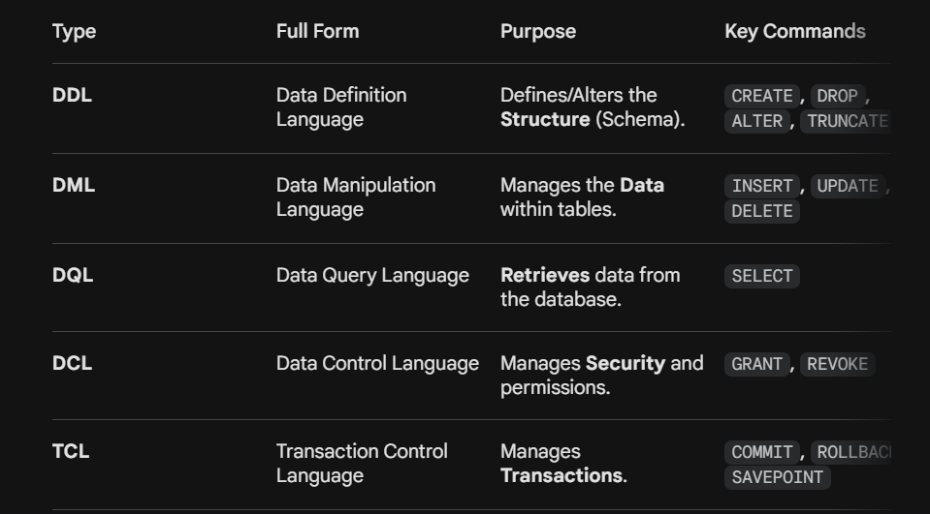
2. SQL JOINS (The Most Important Practical Topic)
A JOIN clause is used to combine rows from two or more tables, based on a related column between them (usually Primary and Foreign keys).

A. INNER JOIN
Returns records that have matching values in both tables.
Scenario: "Find all students who have enrolled in a course." (Students without courses are excluded).

B. OUTER JOINs
Outer joins return the matched records plus some unmatched records.
LEFT (OUTER) JOIN: Returns all records from the left table, and the matched records from the right table. If no match, results from the right side are NULL.
Scenario: "List all students and the courses they are taking, even if they haven't enrolled in any course yet."
RIGHT (OUTER) JOIN: Returns all records from the right table, and the matched records from the left table.
FULL (OUTER) JOIN: Returns all records when there is a match in either left or right table. (Note: MySQL doesn't support this directly; we
use UNION).

C. CROSS JOIN (Cartesian Product)
Returns every possible combination of rows from both tables. ($M \times N$ rows).

D. SELF JOIN
A regular join, but the table is joined with itself.

Scenario: "Find employees and their managers from the same 'Employee' table."

3. NESTED QUERIES (SUBQUERIES)
A Nested Query is a query within another SQL query. The inner query is executed first and its output is used by the outer query.
Types of Subqueries:
- Single-Row Subquery: Returns only one row. Uses operators like =, >, <.
- Multi-Row Subquery: Returns multiple rows. Uses operators like IN, ANY, ALL.
- Correlated Subquery: The inner query depends on the outer query for its values. (Executed once for every row processed by the outer query).
Interview Scenario: "Find employees whose salary is greater than the average salary."
SQL
SELECT Emp_Name
FROM Employees
WHERE Salary > (SELECT AVG(Salary) FROM Employees); -- Inner query finds avg first

4. KEY DIFFERENCES: INNER vs. OUTER JOIN
Feature | INNER JOIN | OUTER JOIN
Result | Only the intersection (matching rows). | Matching rows + Unmatched rows.
Data Loss | Potential loss of data (rows with no matches are hidden). | No data loss from the "preserved" table.
NULL Values | Does not produce NULLs for missing matches. | Produces NULL in columns where a match is missing.
Performance | Generally faster. | Slightly slower due to handling NULLs and extra rows.

5. TOP INTERVIEW QUESTIONS (POV)

Q1: "Which Join is used by default if you just write JOIN?"
- Answer: "In most RDBMS, the JOIN keyword defaults to an INNER JOIN."
Q2: "What is the difference between a Subquery and a Join?"
- Answer: "A Join is used to combine columns from multiple tables. A Subquery is used to filter rows based on a calculated value or a list. Joins are generally faster than Subqueries because the database engine can optimize them better."
Q3: "What is a 'Non-equi Join'?"
- Answer: "Most joins use the equals operator (=). A non-equi join uses operators like <, >, or BETWEEN. For example, joining an 'Employees' table with a 'Salary_Grade' table where the salary falls between a min and max range."
Q4: "Can you explain a 'Lateral Join'?"
- Answer: "A Lateral Join (or Cross Apply in SQL Server) allows a subquery to refer to columns of a preceding table in the FROM clause. It’s like a 'foreach' loop for SQL rows."

1. 2-Tier Architecture (Client-Server)

In 2-Tier architecture, the Client (User Interface) communicates directly with the Database Server.
- How it works: The application logic (the "intelligence") usually resides on the client side. The client sends SQL queries directly to the server, and the server sends back the result set.
- Where it's used: Small organizations, internal departmental tools, or local systems (e.g., a small library management system).
- Pros: Fast performance (fewer "hops"), easy to set up for small groups.
- Cons: Hard to scale; if you have 1,000 clients, you have 1,000 direct connections to the database, which can crash the server.

2. 3-Tier Architecture (Web-based)

In 3-Tier architecture, an intermediate layer—the Application Server (Middleware)—is placed between the Client and the Database.
- Layer 1: Presentation Tier (Client): The UI (Web browser/Mobile App). It knows nothing about the database.
- Layer 2: Application Tier (Business Logic): The "brain." It processes requests, validates data, and decides what to fetch from the DB.
- Layer 3: Data Tier (Database): Only stores and retrieves data as requested by the Application Tier.
- Where it's used: Modern web applications like Amazon, Facebook, and Netflix.

3. Comparison Table (Interview POV)

Feature | 2-Tier Architecture | 3-Tier Architecture
Number of Layers | 2 (Client + Server) | 3 (Client + App Server + DB Server)
Communication | Direct (Client $\leftrightarrow$ DB) | Indirect (Client $\leftrightarrow$ App Server $\leftrightarrow$ DB)
Security | Low: Client has direct DB access/credentials. | High: DB is hidden behind the App Server.
Scalability | Low: Limited by direct connections. | High: App server can handle thousands of users.
Performance | High for very small user counts. | Slightly slower due to intermediate processing.
Maintenance | Difficult (Updates needed on every client). | Easy (Update logic only on the App Server).
Data Independence | Low. | High (You can change DB without changing UI).

4. Why 3-Tier is Preferred (The "Cracker" Answer)

When the interviewer asks: "Why is almost every modern app 3-tier?", give these three points:

- Security: In 2-tier, if the client machine is hacked, the database is exposed. In 3-tier, the client never talks to the DB; it only talks to the API, making it much harder to steal data.
- Scalability: We can add more Application Servers (Horizontal Scaling) to handle more traffic without overloading the Database itself.
- Thin Client: Since the business logic is on the App Server, the mobile or web app can be "lightweight," saving the user's battery and processing power.

5. Typical Interview Scenarios
- Scenario A: "I have a small shop with 2 computers. Which one should I use?"
Answer: 2-tier is sufficient. It's cost-effective and easy to manage locally.
- Scenario B: "What is the role of the Middle Layer in 3-tier?"

Answer: It acts as a gatekeeper. It handles authentication (login), business rules (calculating taxes/discounts), and acts as a load balancer to ensure the database isn't overwhelmed.

Diff between TRUNCATE and DELETE command

the difference between TRUNCATE and DELETE is one of the most frequently asked "trap" questions. The interviewer wants to see if you understand how these commands affect the database at the System (Storage) level versus the Data (Log) level.
Here is the detailed breakdown in a copy-paste format for your preparation.

TRUNCATE vs. DELETE: THE ULTIMATE COMPARISON
1. CORE DEFINITION
- DELETE: A DML (Data Manipulation Language) command used to remove specific rows from a table based on a condition.
- TRUNCATE: A DDL (Data Definition Language) command used to remove all rows from a table by deallocating the data pages used to store the table data.

2. DETAILED DIFFERENCES
FEATURE | DELETE | TRUNCATE
Command Category | DML (Data Manipulation) | DDL (Data Definition)
Where Clause | Supports WHERE to filter specific rows. | Does NOT support WHERE. It’s all or nothing.
Speed | Slower (Deletes rows one by one). | Faster (Deallocates data pages).
Log Space | High (Logs every row deleted). | Minimal (Logs only the page deallocation).
Rollback | Possible (as it is a DML command). | Not Possible (mostly, as it is a DDL/Auto-commit).
Identity/Auto-inc | Does NOT reset the identity counter. | Resets the identity counter to its seed value.
Locks | Row-level locking. | Table-level (Schema) locking.
Triggers | Fires ON DELETE triggers. | Does NOT fire any triggers.

3. REAL-WORLD SCENARIOS (Interview POV)

Scenario A: The "Oops" Moment
Question: "You accidentally deleted 10,000 customers. How do you get them back?"
- If you used DELETE: You can simply use the ROLLBACK command (if you haven't committed) because DELETE is a logged transaction.
- If you used TRUNCATE: You are in trouble. TRUNCATE is a DDL command; it commits immediately. You would have to restore the data from a backup.

Scenario B: Resetting the Counter
Question: "I have a table with Student IDs 1 to 100. I want to clear the table so the next student added starts at ID 1 again. What should I use?"
- Answer: Use TRUNCATE. If you use DELETE, the next student will be assigned ID 101. TRUNCATE resets the auto-increment counter back to 1.

4. THE "HOW IT WORKS" (Deep Technical Insight)
- DELETE works like an eraser on a whiteboard—it goes to each line and wipes it out, keeping track of what it erased in the Undo Log.
- TRUNCATE works like throwing away the entire whiteboard and hanging a brand new, empty one. It doesn't care what was written on the old one; it just marks the storage space as "Available."

5. TOP INTERVIEW "TRAP" QUESTIONS

Q1: "Is TRUNCATE always faster than DELETE?"
- Answer: "Yes, especially for large tables. This is because TRUNCATE does not scan every row and does not generate individual log entries for every row deletion. It simply deallocates the data pages."
Q2: "Can you use TRUNCATE on a table with a Foreign Key?"
- Answer: "In most RDBMS (like MySQL or SQL Server), you cannot TRUNCATE a table if it is being referenced by a Foreign Key from another table. You must either drop the constraint or use DELETE instead."
Q3: "If TRUNCATE is a DDL command, why is it sometimes grouped with DML?"
- Answer: "Because its effect is to delete data (DML's job), but its method is to modify the table's storage structure (DDL's job). Technically, it is DDL."

INTENSION vs. EXTENSION

These terms describe the two different "faces" of a database: the Design and the Data.
Feature | Intension | Extension
Definition | The permanent structure or "Schema" of the database. | The actual data (rows) present in the database at a given moment.
Content | Table names, column names, data types, and constraints. | Tuples, records, and values.
Frequency of Change | Rarely changes. | Changes very frequently (with every Insert/Delete).
Also known as | Schema / Metadata. | Database Instance / Snapshot.
Analogy | The blueprint of a house. | The people living inside the house.
Key Takeaway: The Intension is what you define using DDL (CREATE), while the Extension is what you manage using DML (INSERT).

2. DEFINITION OF A LOCK
In DBMS, a Lock is a mechanism used to manage concurrent access to a data item. It ensures that when multiple transactions are running simultaneously, the data remains consistent and the Isolation property of ACID is maintained.
How a Lock Works:
When a transaction wants to access a data item (like a row or a table), it must first request a lock from the Lock Manager.
- If the lock is granted, the transaction proceeds.
- If the lock is denied (because another transaction is already using it in a conflicting way), the transaction must wait.

3. SHARED LOCK (S) vs. EXCLUSIVE LOCK (X)
These are the two primary modes of locking used in Concurrency Control Protocols.
A. Shared Lock (S)
- Purpose: Used for Reading data.
- Logic: Multiple transactions can hold a Shared Lock on the same data item at the same time. This is because reading doesn't change the data; it's safe for everyone to "look" together.
- Compatibility: It is compatible with other Shared Locks but not with Exclusive Locks.
B. Exclusive Lock (X)
- Purpose: Used for Writing (Insert, Update, Delete).
- Logic: Only one transaction can hold an Exclusive Lock on a data item. No other transaction can hold any lock (S or X) on that item while the X-lock is active.
- Compatibility: It is not compatible with any other lock. It is "Exclusive."

4. LOCK COMPARISON TABLE
Feature | Shared Lock (S) | Exclusive Lock (X)
Operation Type | Read-Only | Read and Write
Multi-User Access | Yes, multiple S-locks allowed. | No, only one X-lock allowed.
Conflict | Conflicts with X-locks. | Conflicts with both S and X locks.
Consistency | Low risk (No data changes). | High risk (Data is being modified).
Analogy | Multiple people reading the same book. | One person writing in a notebook.

5. TOP INTERVIEW QUESTIONS (POV)

Q1: "What is Lock Conversion?"
- Answer: It is the process of changing the lock type.
  - Upgrade: Changing an S-lock to an X-lock (when a transaction reads first and then decides to update).
  - Downgrade: Changing an X-lock to an S-lock.
Q2: "What is a Deadlock in locking?"
- Answer: A deadlock occurs when Transaction $T_1$ holds an X-lock on A and waits for B, while Transaction $T_2$ holds an X-lock on B and waits for A. They will wait forever unless the DBMS intervenes.
Q3: "What is Lock Granularity?"
- Answer: It refers to the "size" of the data being locked. You can lock a Database, a Table, a Page, or a Row.
  - Smaller granularity (Row-level) = Higher concurrency but higher overhead.
  - Larger granularity (Table-level) = Lower overhead but lower concurrency.
Q4: "What happens if a transaction doesn't release its locks?"
- Answer: It leads to blocking, where other users cannot access the data, and can eventually lead to a system-wide slowdown or "Starvation."

